**John Boys (1749-1824)**

Kent, in the Commentaries Caesar writ,

Is term’d the civill’st place of all this isle:

Sweet is the country, because full of riches;

The people liberal, valiant, active, wealthy.

(Shakespeare, _*Second Part of King Henry VI_*, Act V, Scene 7)

This epigraph, which clearly underlines his affection for and pride in Kent, was given by John Boys to _*A General View of the Agriculture of the County of Kent, with Observations on the Means of its Improvement_* which he prepared for the Board of Agriculture and which appeared in 1796. His original version had appeared in 1794, and this was an expanded and revised edition in line with the uniform model provided by the Board of Agriculture, so that ‘information respecting the State of the kingdom, and Agricultural Knowledge in general, will be attainable with every possible advantage’ (Boys 1796, ix). It is possible that he was invited to compile this report because he was one of the Stewards of the Kent Society for the Encouragement of Agriculture and Industry, established in Canterbury a few years earlier in January 1793. <https://vufind.org/advanced_demo/Record/1028040> (1)

**BETTESHANGER**

Boys farmed at Betteshanger Home Farm, about five miles inland from Deal. He was a scion of the Boys family who had arrived with William the Conqueror, and whose members had lived in East Kent since at least the fourteenth century, notably at Fredville near Nonington between the fifteenth and seventeenth centuries, as well as at Betteshanger from the early seventeenth century.[1] However, Boys was a tenant farmer, rather than an owner. An earlier, distantly related Boys, Edward Grotius (1679-1706), had died without issue and bequeathed the Betteshanger estate to a cousin who sold it the Morrice family in about 1713, from whom John Boys leased the property.[2]

The Morrice family sold the Betteshanger estate in 1850 to Sir Walter James, who in 1884 became Lord Northbourne. His descendent, the fourth [Lord Northbourne](/20c/20c-northbourne-biography), would follow in Boys’ footsteps, confirming Betteshanger as an important crucible of agricultural wisdom and innovation when he held the 1939 Betteshanger Summer School and Conference on Bio-dynamic Farming, and by coining the term ‘organic farming’ in *_Look to the Land_*, his seminal work of 1940. <http://www.dover-kent.com/VILLAGES/24-Betteshanger.html>

<https://commons.wikimedia.org/wiki/File:Home_Farm_and_Home_Farm_cottages,_Little_Betteshanger._-_geograph.org.uk_-_304375.jpg>

***A GENERAL VIEW OF THE AGRICULTURE OF THE COUNTY OF KENT***

Boys’ report extends to over 200 pages, and he begins by describing the county of Kent, giving its location and dimensions, and then moves on to a description of its [geography](/landscape): the two chains of hills, the Isles of Thanet and Sheppey, the Weald, and Romney Marsh. He highlights the many different types of soil which account for the various systems of management and production, and describes the types of buildings and the modes of occupation of farms, including leases, tithes, rents and poor rates.

**IMPLEMENTS**

Boys describes implements used, singling out the Kent turn-wrest plough. For all sorts of soils, and for all required depths of ploughing, it is the best he has ever seen and tried. <https://www.agriculturalmuseumbrook.org.uk/explore/collections/plough> He moves on to machines for seed drilling, harrows, and carriages called hutches for carrying corn to market. He tells us wheat is reaped with a toothed sickle, while barley and oats are mown with a long scythe and cradle. He describes a threshing mill which he himself designed, and which requires four horses, eight men and four boys to operate, ‘threshing every kind of corn cleaner that it is usually done by the common mode’.[3] For hop grounds, an oast, built substantially with the ‘requisite stowage room’ is necessary.

(3)<https://www.google.com/url?sa=i&url=https%3A%2F%2Fwww.moorgatebooks.com%2F09%2Fanne-de-bourgh-heiress-landowner-change-leader%2Fturn-wrest-plow-boys-1796-pdf-p-71-jpeg%2F&psig=AOvVaw0zsZ8ybzOaepMSEKSSYEPy&ust=1633445945162000&source=images&cd=vfe&ved=2ahUKEwimsOu7grHzAhVI-4UKHYjeBp4Qr4kDegQIARBF>

**CROPS: ROTATION AND FALLOWING**

Boys is writing fifty years after ‘Turnip’ Townshend’s introduction of the Norfolk four-course rotation scheme whereby instead of a fallow year turnips and clover are planted alternately with wheat and other cereals to replenish the nitrogen in the soil. He remarks that ‘[t]here is not any part of agriculture which has occasioned more discussion and controversy among writers on husbandry, than this subject of Fallowing’.[4] In all he lists nine different systems found in the county, rotating over periods of three to seven years. He details the various crops: most commonly grown are wheat, barley, beans, oats, peas, canary seed, radish seed, turnips and cole (rape) seed, while some less often grown include tares (a vetch), clover, trefoil, sainfoin, lucern, burnet, spinach, kidney beans, cress, potatoes, flax, cabbage, and two plants used for dyeing, woad and madder. However, while he is even-handed, from his detailed instructions on how to make a good fallow, it is difficult not to believe that he himself favoured fallowing. Nevertheless, twenty-five years later William Cobbett would find very few fallow fields in Thanet, writing: ‘When I got upon the corn land in the Isle of Thanet, I got into a garden indeed. There is hardly any fallow; comparatively few turnhips [sic]. It is a country of corn’.[5] Cobbett frequently remarks on the excellence of the wheat crop when in early September 1823 he passes from Folkestone via Dover to Thanet, ‘that spot so famous for corn’.[6] Here Cobbett is echoing Boys who remarks:

In short, is there another district in Great Britain, or in the World, of the same extent, in such a perfect state of cultivation, where the Farmers are so wealthy and intelligent, where land, naturally of so inferior a quality, is let for so much money and produces such abundant crops?[7]

Hay is usually set up in stacks, either in the marshes near a foddering lodge, or in farm-yards near the marshes for fattening bullock. Boys gives a hint of the burgeoning importance of Thanet as a resort from the mid-eighteenth century when he notes that hay is sold to innkeepers at Margate or Ramsgate.[8]

**WOODLANDS, HOPS AND ORCHARDS**

Boys reproduces a table detailing various woodlands in the county.[9] He tells us that the woodlands between Chatham Hill and Charing provide poles, stakes and binders of various lengths. The best are cut from chestnut, ash, willow and maple, while the second best are cut from oak, gascoign (a form of wild cherry), red birch, beech and hornbeam. Stakes and binders are also cut from hazel. Props to be used in the coal-mines at Newcastle are cut from oak and birch, six feet four or five inches long.[10]

Other poles would be used for hops. The Hop Grounds in the vicinity of Canterbury and Maidstone are the principle ones in the county, with those of Canterbury superior to those of Maidstone.[11] This contemporary hop field lies between Ash and Wingham, just south of Canterbury and two or three miles from Each End where Boys moved to when he left Betteshanger and somewhere he would have known well. (4) <https://commons.wikimedia.org/wiki/File:Hop_Fields_along_Pedding_Lane_-_geograph.org.uk_-_1974865.jpg>

The area around Maidstone has plenty of orchards, principally apples and cherries, as it does today, as well as filbert plantations. Apples are grown both for cider and for domestic use, and among those Boys lists are varieties still grown commercially today such as royal russet and Ribstone pippin, while others are still available from specialist nurseries. Apples were shipped along the Medway and thence to London and also to Newcastle in returning colliers. The bulk of the filbert harvest was shipped to London. File:Cherry orchard - geograph.org.uk - 4704.jpg|Cherry_orchard_-_geograph.org.uk_-_4704 The area around Sandwich also had plenty of orchards. (5)

**LIVESTOCK**

Boys devotes a chapter to livestock, starting with cattle, saying there is ‘no particular breed which may be allowed the appellation of Kentish Cattle’.[12] The beef cattle are bought in from Wales by graziers to be fattened on the Kent marshes until they are fit for the butcher. For the most part, dairy cows are selected from the Welsh droves, but in recent years a few dairy cows, remarkable for the richness of their milk, have been brought from Alderney and Guernsey ‘for the use of the dairies of gentlemens [sic] families’.[13] Moving on to sheep, he observes that Kent has long been famous for the Romney Marsh breed, known at Smithfield Market as Kent sheep, valuable not only for their meat, but for their very long fine wool. While Boys himself seems to have had a reputation for his South Downs sheep, being complimented on five South Down ewes which he exhibited at Lord Somerville’s Spring Cattle Show in 1809, he makes little mention of this breed in his *Survey*, apart from the illustration of ‘A Small South Down Ram belonging to Mr. Boys’.[14] Cobbett comments on how, when having travelled across East Kent he arrives near Tonbridge where he begins to see South Down sheep again for the first since he left Tenterden, implying that he saw none in the area east of those towns.[15] Apart from sheep, the main livestock production of the county at large includes horses, hogs, poultry, rabbits, pigeons and bees. (6)

**LAND IMPROVEMENT/OBSTACLES TO IMPROVEMENT**

Boys begins his chapter on ‘Improvements’ with a section on drainage, saying that this is a subject of infinite importance to the prosperity of the kingdom, and he describes the various methods of draining. As one of Kent’s commissioners for sewers, dealing with land drainage and flood defence, Boys was involved in the drainage of the marshes around Eastry and Finglesham Brooks, streams which break through the chalk ridge at Hacklinge between Deal and Sandwich, and feed into the North Stream and thence into the Stour. He describes a pump driven by a wind mill installed at Cottington, on the seaward side of the ridge. Mill pumps of this kind had been found in the Cambridgeshire Fens from the later sixteenth century, but the manner in which Boys singles this out suggests it is an innovation in East Kent.[16] <https://en.wikisource.org/wiki/Dictionary_of_National_Biography,_1885-1900/Boys,_John_(1749-1824)>

(7) <https://commons.wikimedia.org/wiki/Category:Hacklinge#/media/File:View_along_the_North_Stream,_Ham_-_geograph.org.uk_-_578537.jpg>

His other sections include paring and burning, and manuring: as well as dung he advocates seaweed which is plentiful around the coast. He lists waste lands, neglected woods, and impoverished commons, and says he is taking the liberty of suggesting to the Board of Agriculture that they should approach the legislature with the view to introducing an act of inclosure, in order to put these lands under proper systems of management.

In a short concluding chapter, Boys lists the principle obstacles to the general improvement of the county which include the payment of tithes in kind, the corn-laws, and the prohibition to export wool in its raw state. He also lists the rights of commonage on heathlands as being an obstacle to their improvement, along with short leases which offer no incentive to improve the land.

**HIGHWAYS**

Boys considers the highways, and observes that while the principal road in the county, from London to Canterbury, is ‘kept in excellent order by the commissioners’, it is ‘somewhat extraordinary that their power is not extended eastward to Deal, where there is such a resort of shipping’[17] (Boys was writing shortly before the Napoleonic wars when Admiral Lord Nelson would set up his shore Headquarters in what is now the Royal Hotel in Deal). He notes that the turnpike roads are in general good, apart from some in the Weald which are very frequently impassable in winter. In the first version of his Review he tells us that the difference between the shoulders of the axle trees of waggons and carts is two inches greater in the eastern part of Kent than it is in Sittingbourne, and two inches less in the western part of Kent, making it difficult for carriages from one part of the district to pass in the deep channels of the other.[18]

**BOYS THE INNOVATOR**

Boys was an innovator. Not only did he design the threshing mill described above, he also experimented with the long-term preservation of potatoes by drying, both in slices and as meal. The potatoes were then transported in kegs to St Helena, and were pronounced on arrival to ‘retain the essential qualities of the potatoe [sic], unimpaired, though somewhat altered in colour’.[19]

**BOYS’ REPUTATION**

According to *Gentleman’s Magazine* for 1825, Boys’ report was ‘accorded the palm amongst County reports of agriculture, “for soundness of judgment and enlightened practical views”’. <https://en.wikisource.org/wiki/Men_of_Kent_and_Kentishmen/John_Boys,_of_Betshanger>

At times Boys quotes extensively from Edward Hasted’s _*History and Topographical Survey of the County of Kent_* and Hasted returns the compliment in his 1800 edition, saying:

The house [pertaining to the estate of Little Betteshanger] is large, and has been the residence of gentlemen; a family of the name of Boys has inhabited it for many years, Mr. John Boys now resides in it, a gentleman, whose scientific knowledge in husbandry is well known, especially by the publication of the Agricultural Society of the state of it, and its improvements in this county, for which they are, I believe, wholly indebted to him. (<https://www.british-history.ac.uk/survey-kent/vol9/pp583-604>)

Boys and his wife later moved from Betteshanger to Each End, between Ash and Wingham. He is buried at St Mary the Virgin, Wingham, where there is a memorial to him. (8)

**REFERENCES**

Boys, John. _*General View of the Agriculture of the County of Kent, with Observations on the Means of its Improvement_*. P. Norbury, 1794. (There is a copy in the Historical Collection in the Augustine House Library of CCCU, class mark 333.76094223 BOY.)

--. _*A General View of the Agriculture of the County of Kent, with Observations on the Means of its Improvement_.* G. Nicol, 1796.

Cobbett, William. _*Rural Rides_*. 1830. Penguin Classics, 1985.

Hasted, Edward. 'Parishes: Northborne', in _The History and Topographical Survey of the County of Kent:_ Volume 9 (Canterbury, 1800). 583-604.

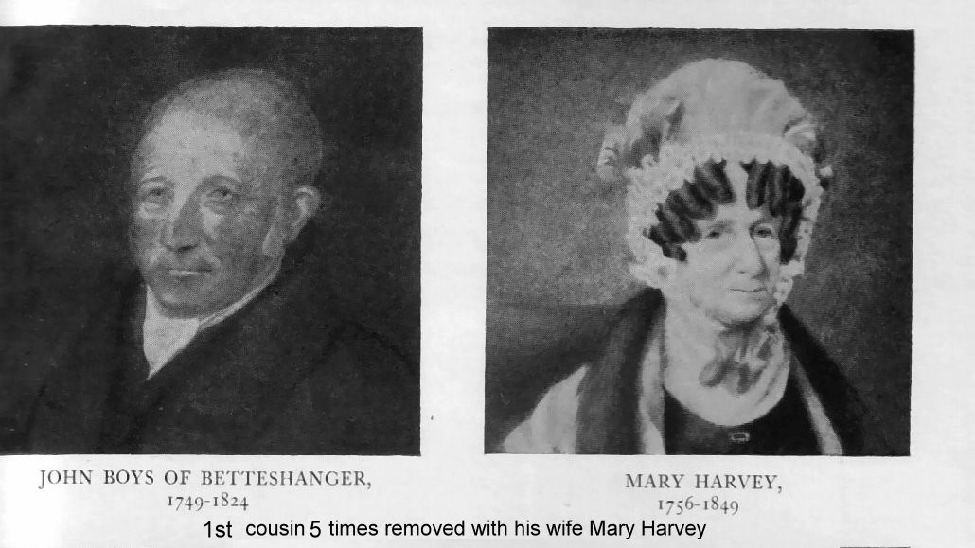

https://www.wikitree.com/photo/jpg/Boys-333 (1)

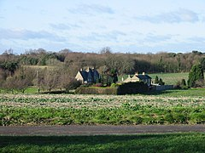 (2)

 (3) I have permission from the person whose website I found this on to use the image.

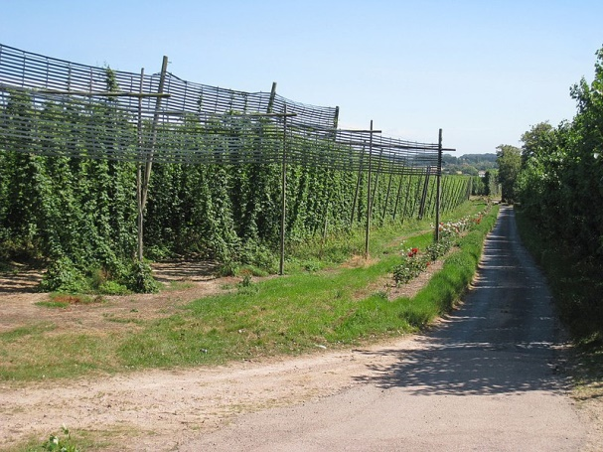 (4)

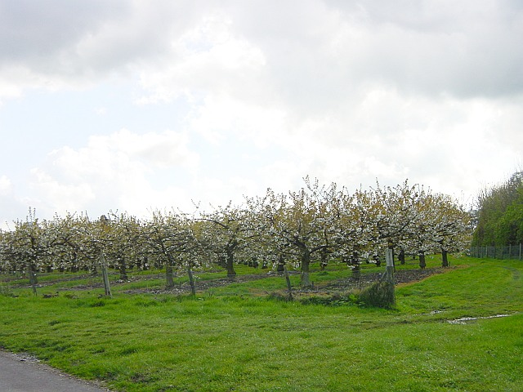 (5)

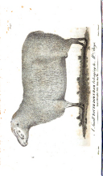

(6) Image of ram from Boys 1796, facing page 24.

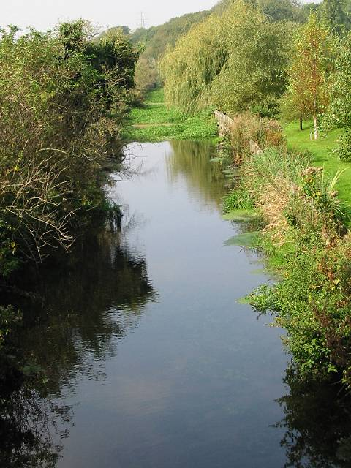 (7)

(8) Image of Boys’ memorial in St Mary the Virgin, Wingham.

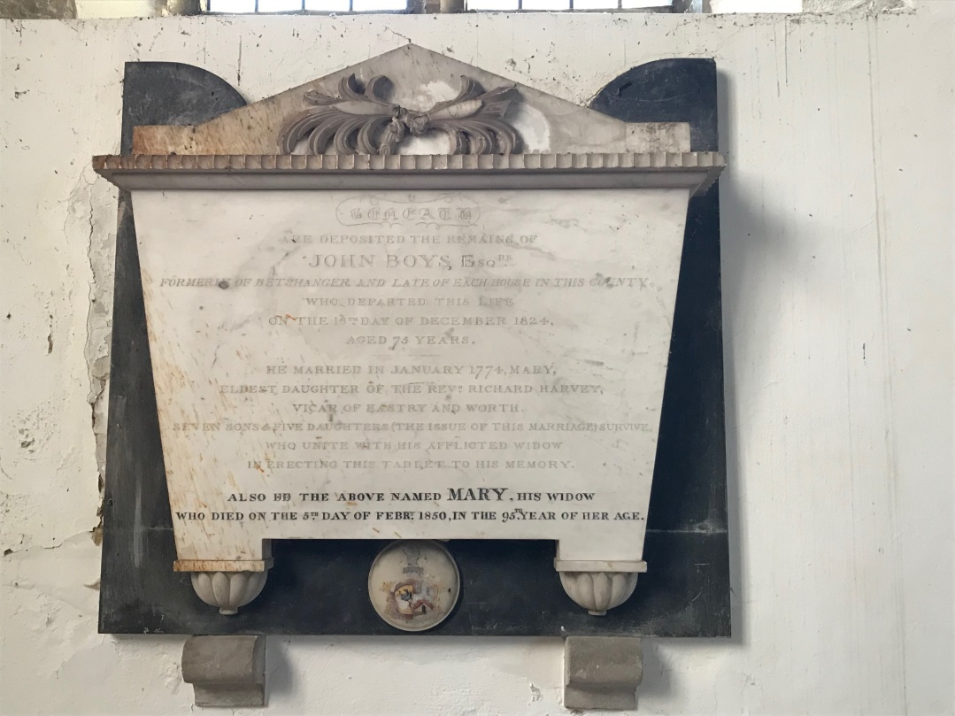

Photo credit Steve Sheath

1. An extensive Boys pedigree is found at <https://www.kent-opc.org/families/BOYSMediaeval30.pdf>

   John Boys first appears on page 40, and his descendants start at page 60. Other Betteshanger Boys, many of whom have memorials in the Church of St Mary the Virgin, Betteshanger, are found on page 25. See also

   <https://www.kentarchaeology.org.uk/Research/Pub/ArchCant/Vol.079%20-%201964/079-04.pdf>
2. <https://www.british-history.ac.uk/survey-kent/vol10/pp44-49>
3. Boys 1796, 51.
4. Boys 1796, 57-61.
5. Cobbett, 205.
6. Cobbett, 196.
7. Boys 1796, 4.
8. Boys 1796, 110.
9. Boys 1796, between 126 and 127.
10. Here Boys is citing R. Tilden, 1796, 125.
11. Boys 1796, 117.
12. Boys 1796, 147.
13. Boys 1796, 148.
14. Boys 1796, facing page 24.
15. Cobbett, 213.
16. Boys, 1796 132-133.
17. Boys 1796, 168.
18. Boys 1794, 90.
19. Boys, 198-199.This was twenty years before Napoleon arrived on St Helena. By coincidence, John Boys’ fourth son, Richard, was a chaplain in the East India Company, serving at St Helena at the time of Napoleon’s exile.